Name: K.Poorna chandu
Reg No: 192312585
Subject: ECA56 –5G / 6G Communication Systems
EXPERIMENT:-9 Massive MIMO Capacity vs SNR and Gain Using MATLAB
Aim:-
To analyze the performance of a Massive MIMO system by studying channel capacity, signal-to-noise ratio (SNR), and antenna gain using MATLAB.
Objectives
Objective – 1: Analyze Channel Capacity (bps/Hz)
Analyze the channel capacity of a Massive MIMO system for different signal-to-noise ratio (SNR) values using MATLAB. Observe how channel capacity increases with improving signal quality based on the Shannon capacity principle.
MATLAB Code:
clc;
clear;
close all;
snr = 0:5:30;
snr_linear = 10.^(snr/10);
capacity = log2(1 + snr_linear);
figure;
plot(snr,capacity,'-o','LineWidth',2,'MarkerSize',6);
grid on;
xlabel('SNR (dB)');
ylabel('Channel Capacity (bps/Hz)');
title('Channel Capacity vs SNR');
Expected Output 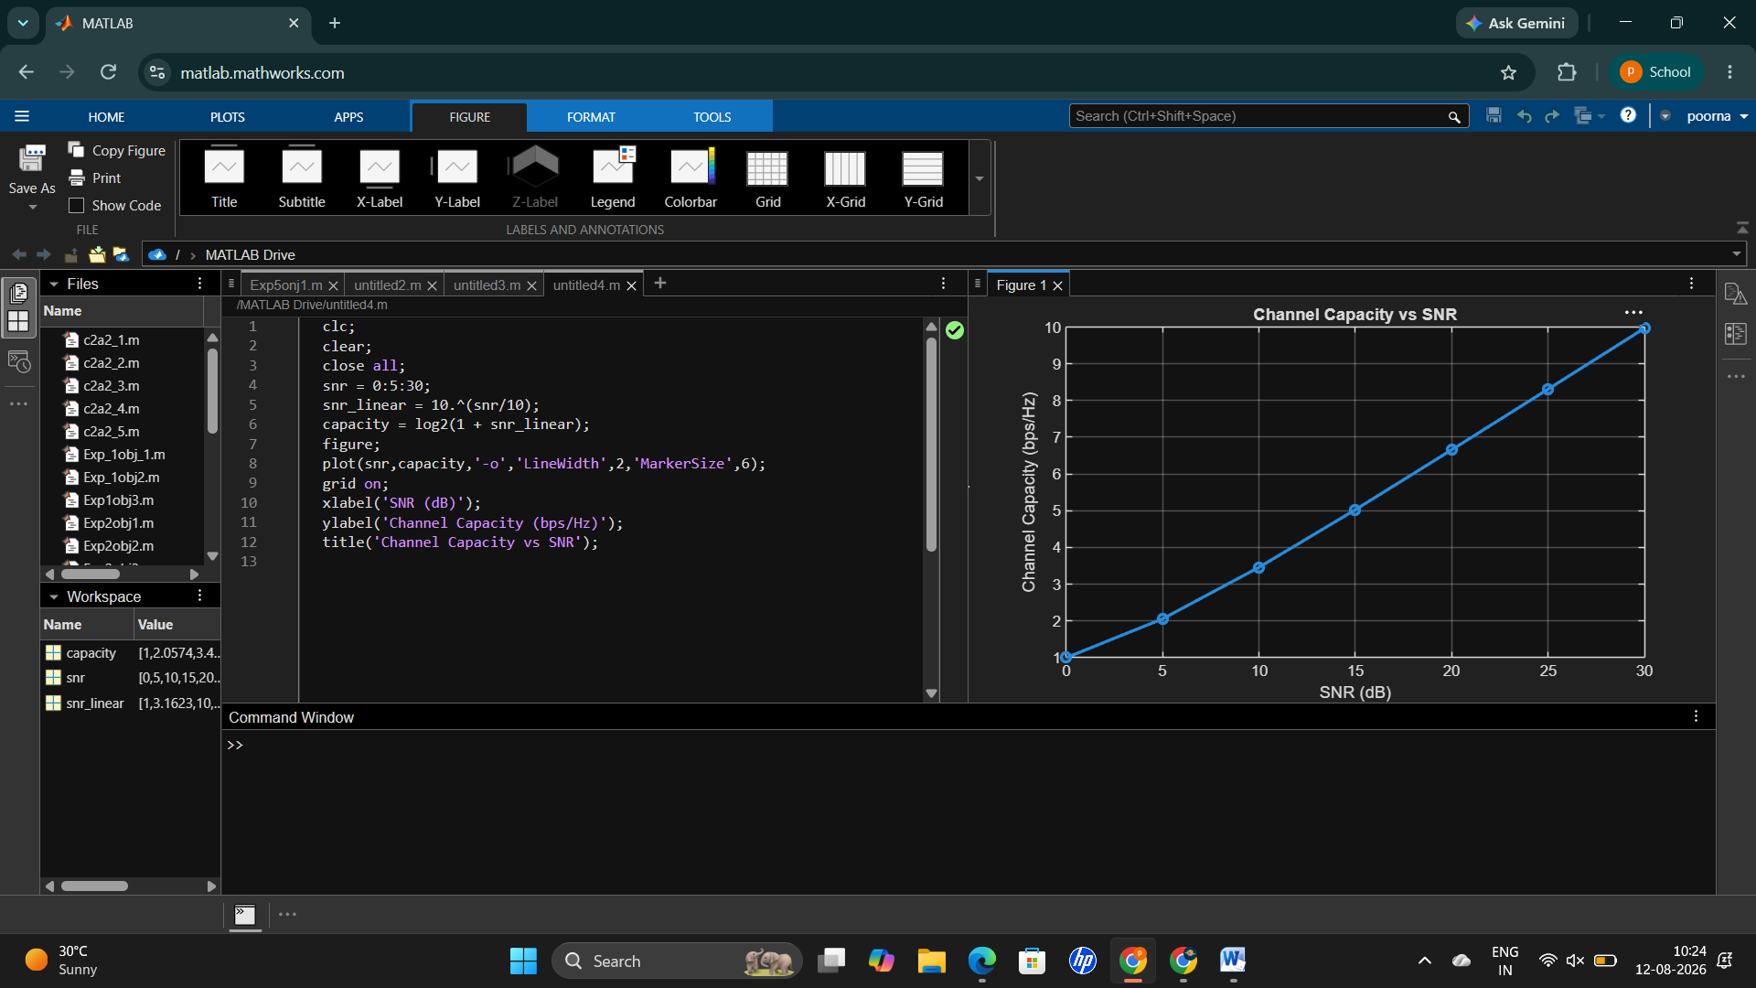
Objective – 2 Bar graph comparing SNR values under different communication scenarios.
Analyze the channel capacity of a Massive MIMO system for different signal-to-noise ratio (SNR) values using MATLAB. Observe how channel capacity increases with improving signal quality based on the Shannon capacity principle.
MATLAB Code:
clc;
clear;
close all;
snr = 0:5:30;
snr_linear = 10.^(snr/10);
capacity = log2(1 + snr_linear);
figure;
plot(snr,capacity,'-o','LineWidth',2,'MarkerSize',6);
grid on;
xlabel('SNR (dB)');
ylabel('Channel Capacity (bps/Hz)');
title('Channel Capacity vs SNR');
Expected Output
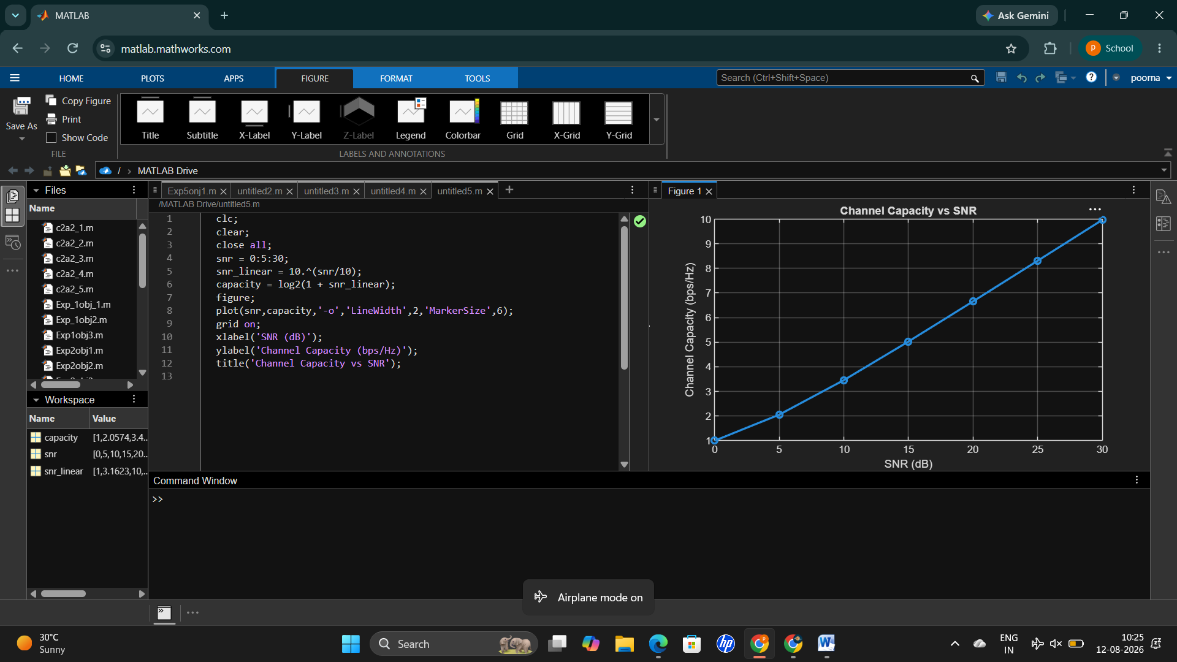
Objective – 3 Bar graph showing Antenna Gain for different antenna array sizes. MATLAB Code:
clc;
clear;
close all;
antennas = [4 8 16 32 64]; % Number of Antenna Elements gain = 10*log10(antennas); % Antenna Gain (dB)
figure
bar(antennas, gain)
grid on
xlabel('Number of Antenna Elements')
ylabel('Antenna Gain (dB)')
title('Antenna Gain for Different Antenna Array Sizes')
Expected Output 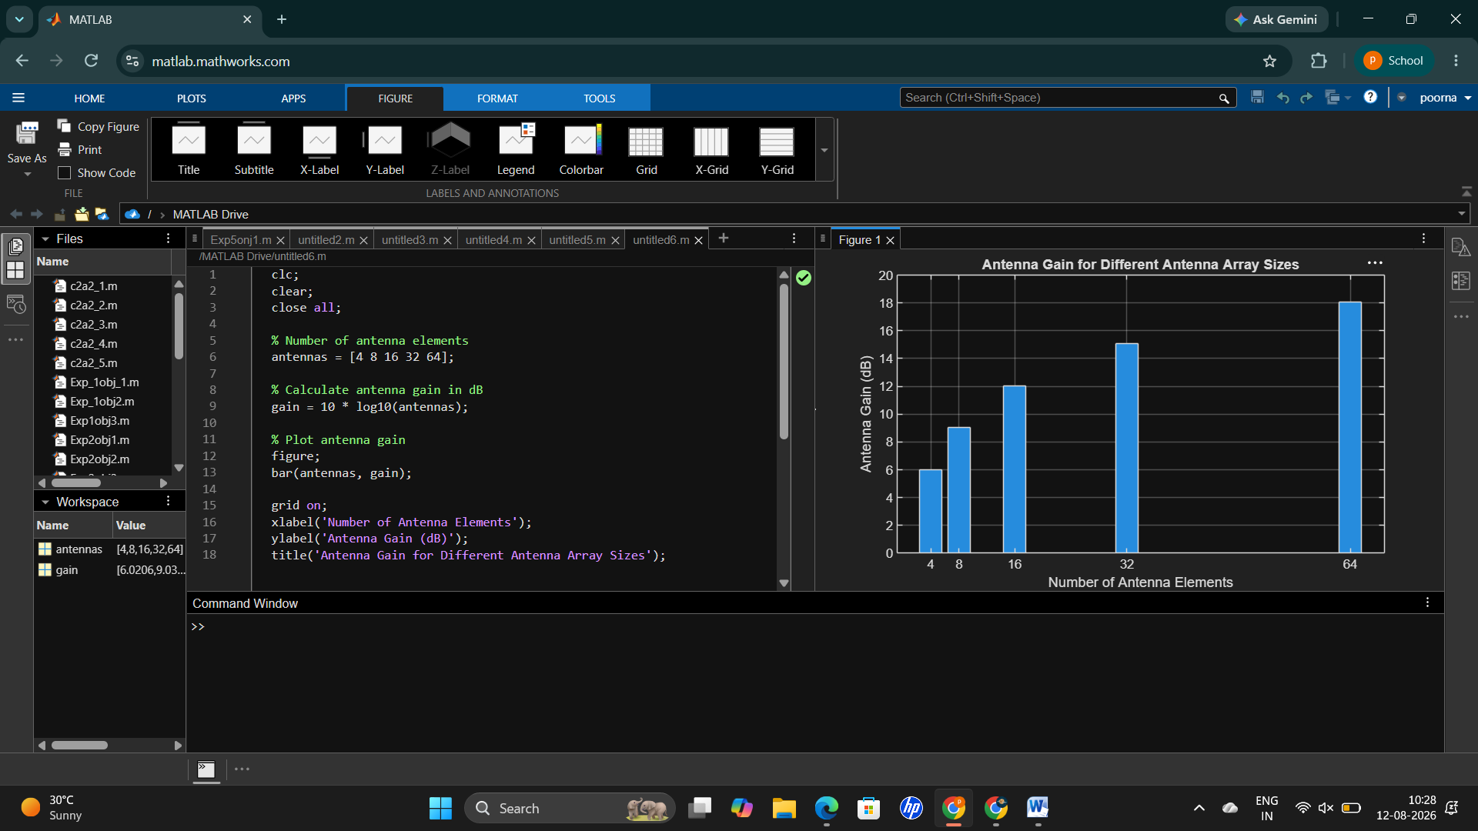 Result
The MATLAB analysis successfully demonstrated the relationship between channel capacity, signal-to-noise ratio, and antenna gain in a Massive MIMO system. The results showed that higher SNR and larger antenna arrays improve communication performance by increasing channel capacity and directional gain.

